Integrate NodeJS with Gemini API’s.

Source: <https://ai.google.dev/gemini-api/docs/text-generation?lang=node>

**Get Gemini API Key**

Source: <https://aistudio.google.com/>

**How to Create a Project in Google**

Source: <https://console.cloud.google.com>

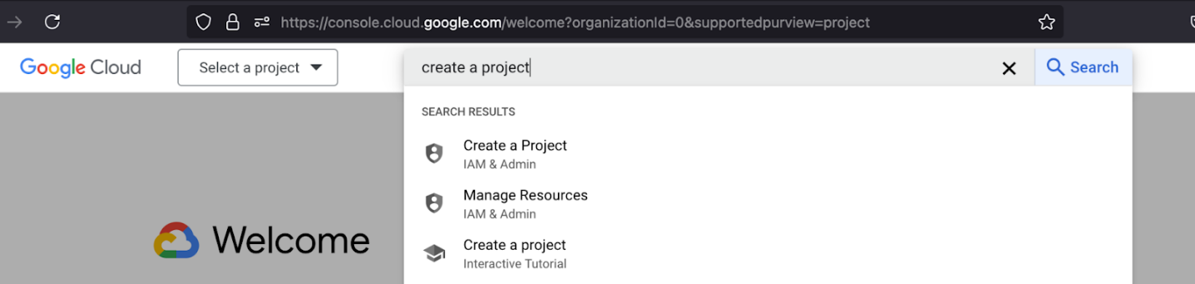

**Generate text using the Gemini API**

The simplest way to generate text using the Gemini API is to provide the model with a single text-only input, as shown in this example:

|  |
| --- |
| const gemini_api_key = process.env.API_KEY; const googleAI = new GoogleGenerativeAI(gemini_api_key); const geminiModel = googleAI.getGenerativeModel({   model: "gemini-1.5-flash", });  var question = "what is the value of pie in maths ?"; const generate = async (question) => {   try {     const prompt = question;     const result = await geminiModel.generateContent(prompt);     const response = result.response;     console.log(response.text());     return response.text();   } catch (error) {     console.log("response error", error);   } };  app.post('/api/content', async (req, res) => {     let data = req.body.question;     var result = await generate(data);     console.log(result);     res.json({"result" : result}); }) |

* Dependencies we need in our projects

|  |
| --- |
| const { GoogleGenerativeAI } = require("@google/generative-ai"); require('dotenv').config(); const express = require('express') const axios = require('axios') const multer = require('multer'); const bodyParser = require('body-parser'); const fs = require('fs') const path = require('path'); const app = express() const port = process.env.PORT || 3000 app.use(bodyParser.json()); app.use(express.json()) app.get('/', (req, res) => {   res.send('Hello World!') }) |